

Dr. Andrew, Ryan inc.

2019-04-14

Dr. Ryan

084 Williams Route, Port Jacob, MT 78408

Phone: 4808650430

Fax: 654328250

**Re:** Courtney, Roberts

**PHN:** 5151539638

**Birthdate:** 18-Oct-1985

**Address:** 711 Johnson Valley Suite 751, Chelseaborough, NY 33049

**Patient number:** 6133417276

To Whom It May Concern:

This is a medical letter to state the above patient is pregnant with expected delivery date of 25-Sep-2025. Hoping this information is satisfactory for your requirements.

Thank you.

Sincerely,

Dr. Andrew, Ryan

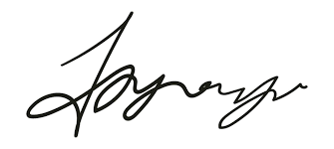

FRCS© NCMP

Clinical Assistant Professor, UBC

Department of Obstetrics and Gynecology SMH